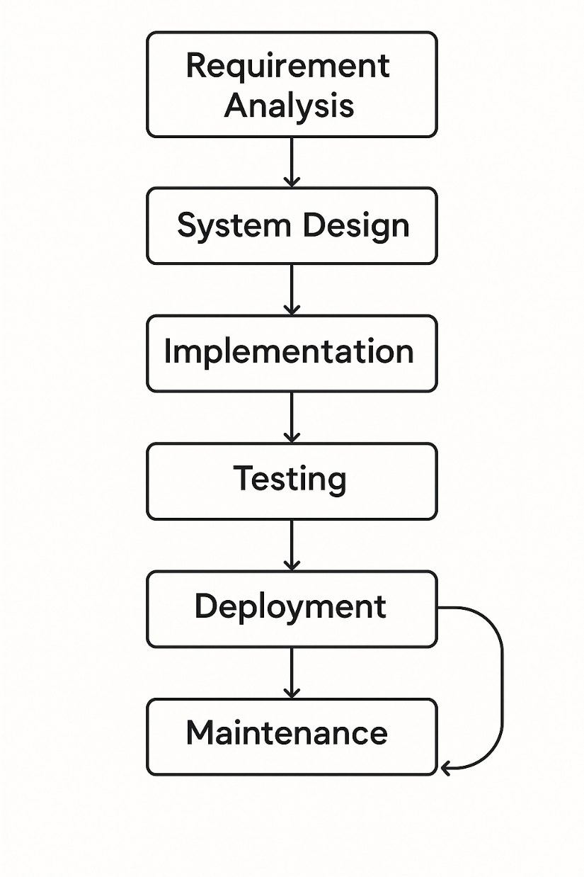

1. Working Flow Of Gender & Age Prediction

CNN

Model

Preprocessing

(Resize+Grayscale)

Image Upload

Display Result

Gender Prediction

Age Prediction

1. Working flow of deployed App (Gender & Age Prediction)